**Computer Network**

**Ethernet and ARP v8.0**

***Lecturer: Mr. Nguyễn Mạnh Thìn***

***Student: Trần Quốc Anh - 1852247***

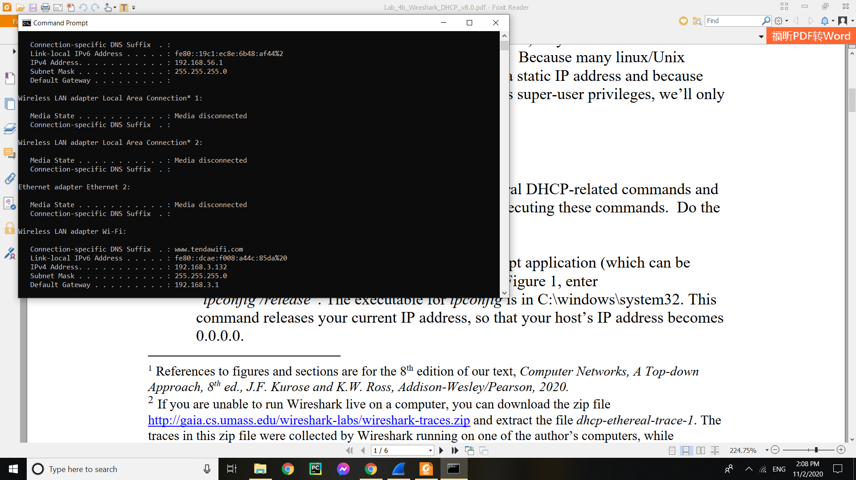

1. What is the 48-bit Ethernet address of your computer?

* The Ethernet address of my computer is 90:32:4b:2d:67:d1

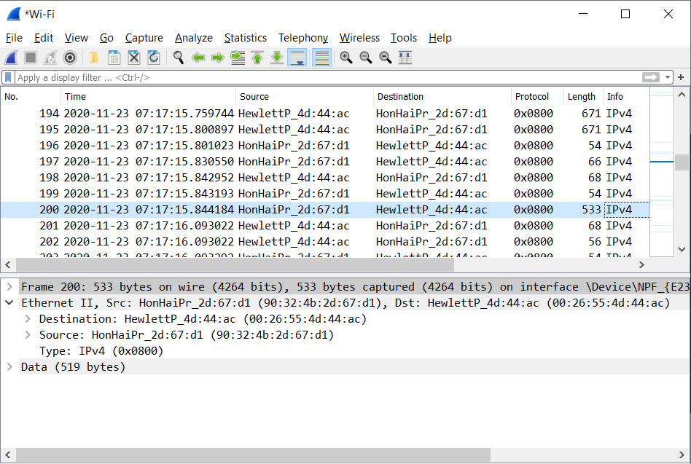

1. What is the 48-bit destination address in the Ethernet frame? Is this the Ethernet address of gaia.cs.umass.edu? (Hint: the answer is no). What device has this as its Ethernet address?

* The 48-bit destination address in the Ethernet frame is 00:26:55:4d:44:ac
* This is not the Ethernet address of gaia.cs.umass.edu, it is the address of the router that my computer has to go through in order to reach the destination.

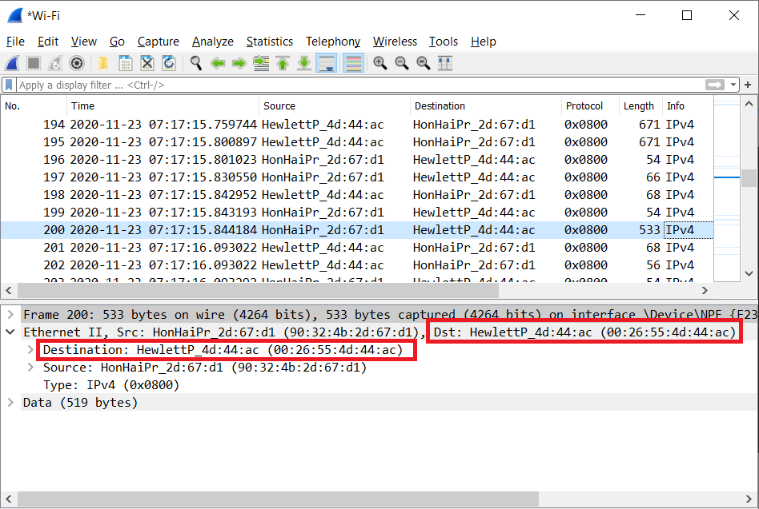

1. Give the hexadecimal value for the two-byte Frame type field. What upper layer protocol does this correspond to?

* The hexadecimal value is 0x0800. This corresponds to the IP protocol.

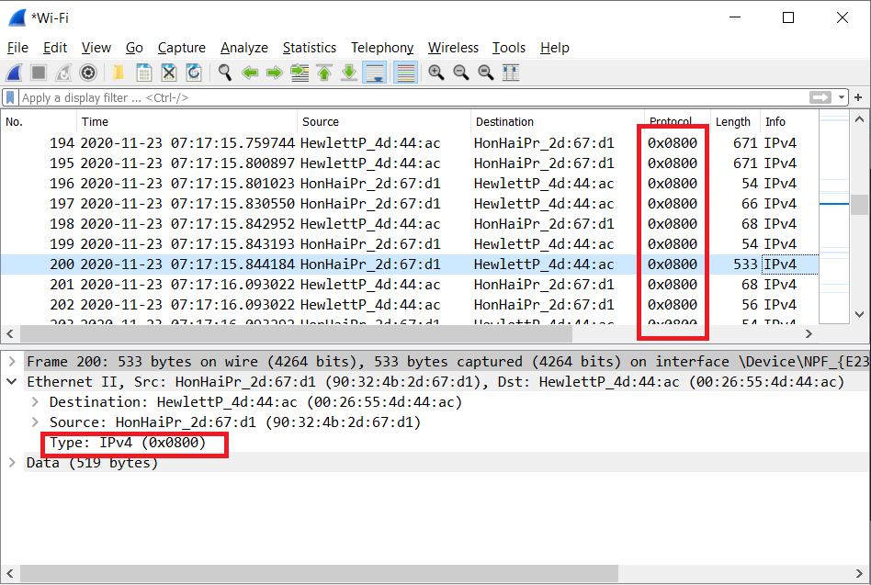

1. How many bytes from the very start of the Ethernet frame does the ASCII “G” in “GET” appear in the Ethernet frame?

* After 54 bytes the “G” in “GET” appears.

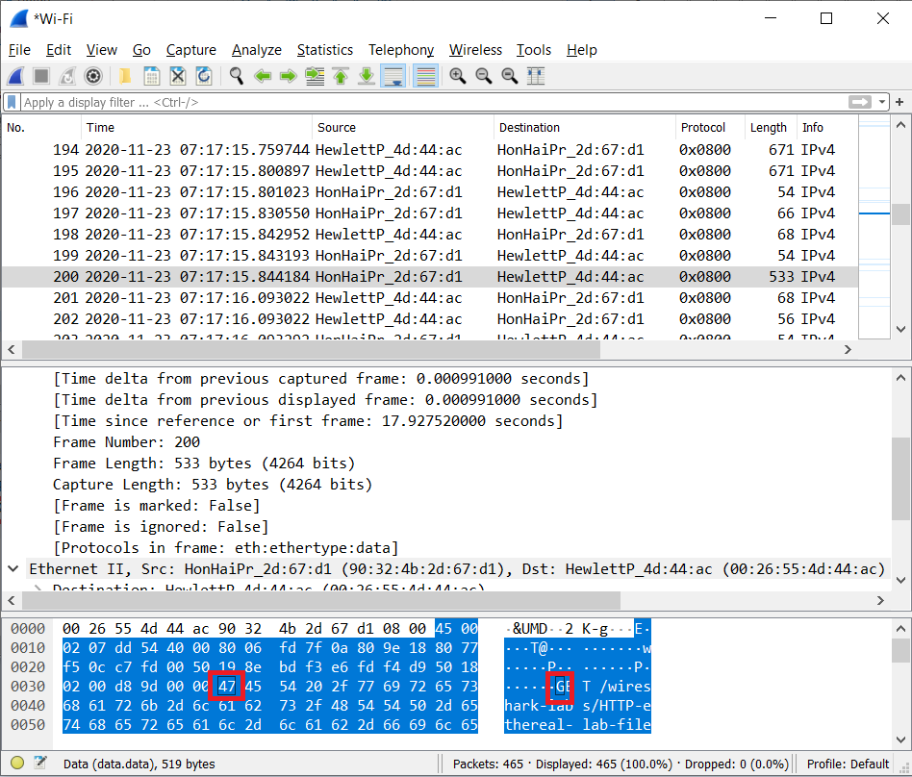

1. What is the value of the Ethernet source address? Is this the address of your computer, or of gaia.cs.umass.edu (Hint: the answer is no). What device has this as its Ethernet address?

* The value of the source address is 00:26:55:4d:44:ac. This is the address of the router that has received the ok and forwarded it to my computer.

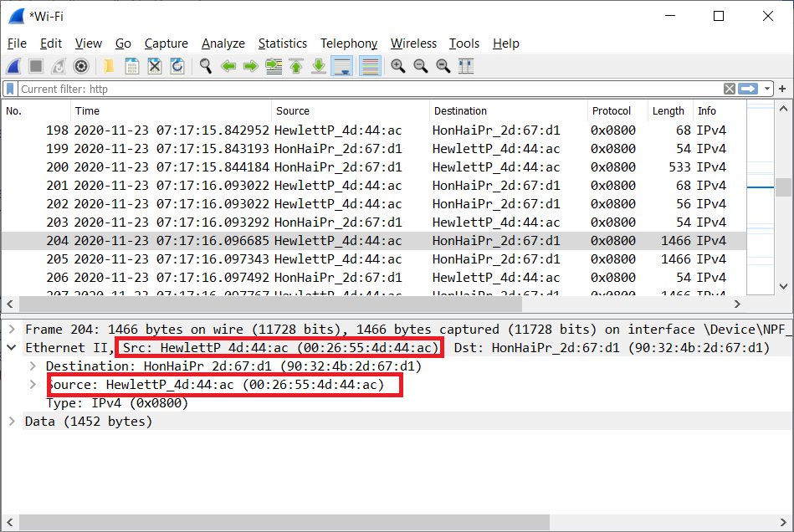

1. What is the destination address in the Ethernet frame? Is this the Ethernet address of your computer?

* The value of the destination address is 90:32:4b:2d:67:d1. This is the address of my computer.

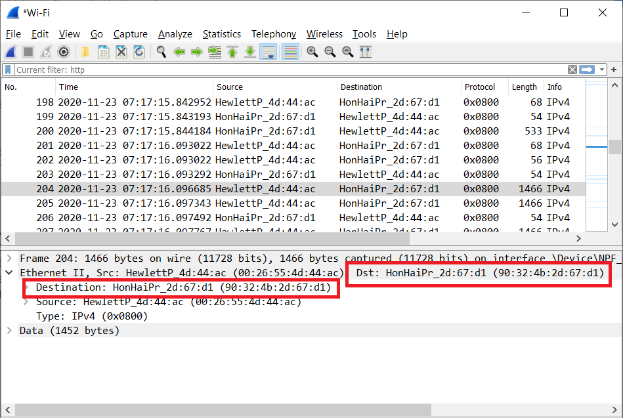

1. Give the hexadecimal value for the two-byte Frame type field. What upper layer protocol does this correspond to?

* The hexadecimal value is 0x0800. This corresponds to the IP protocol.

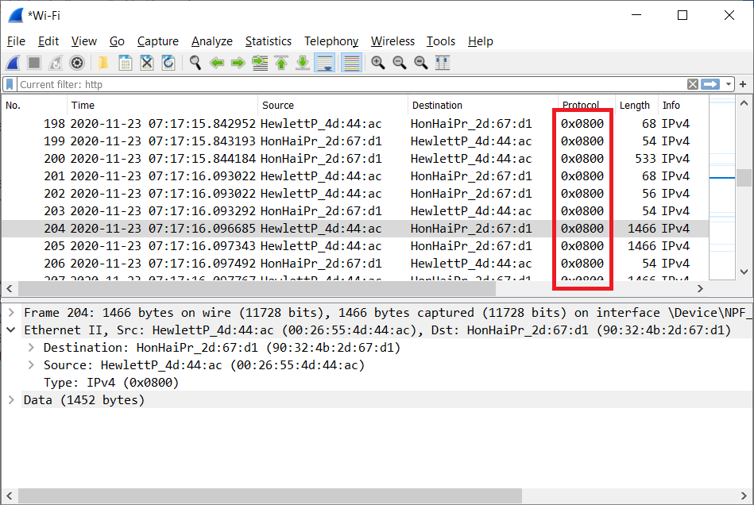

1. How many bytes from the very start of the Ethernet frame does the ASCII “O” in “OK” (i.e., the HTTP response code) appear in the Ethernet frame?

* After 67 bytes the “O” in “OK” appears.

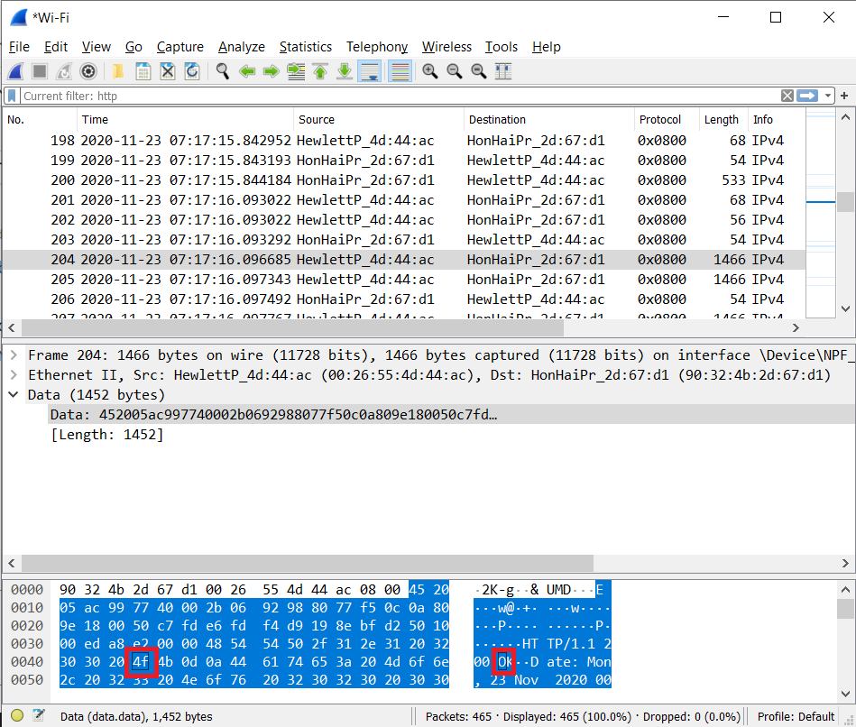

1. Write down the contents of your computer’s ARP cache. What is the meaning of each column value?

* The Internet Address column contains the IP address, the Physical Address column contains the MAC address, and the type indicates the protocol type.

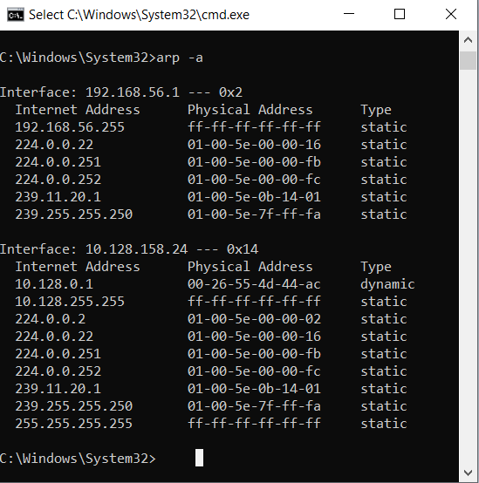

1. What are the hexadecimal values for the source and destination addresses in the Ethernet frame containing the ARP request message?

* The hex values in the frame are for destination: 00:26:55:4d:44:ac source: 90:32:4b:2d:67:d1

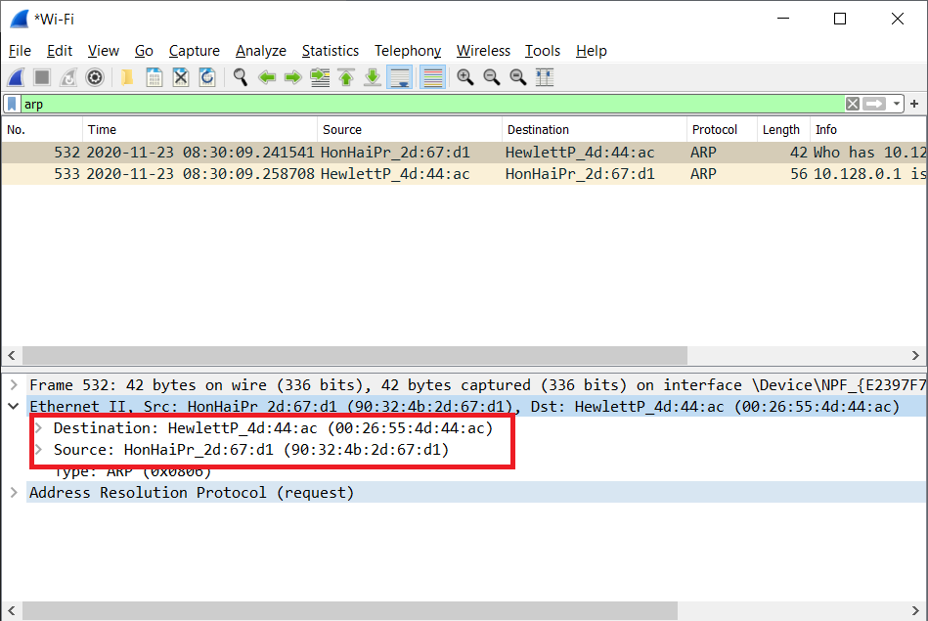

1. Give the hexadecimal value for the two-byte Ethernet Frame type field. What upper layer protocol does this correspond to?

* The hex value for the type frame is 0x0806, which corresponds to ARP.

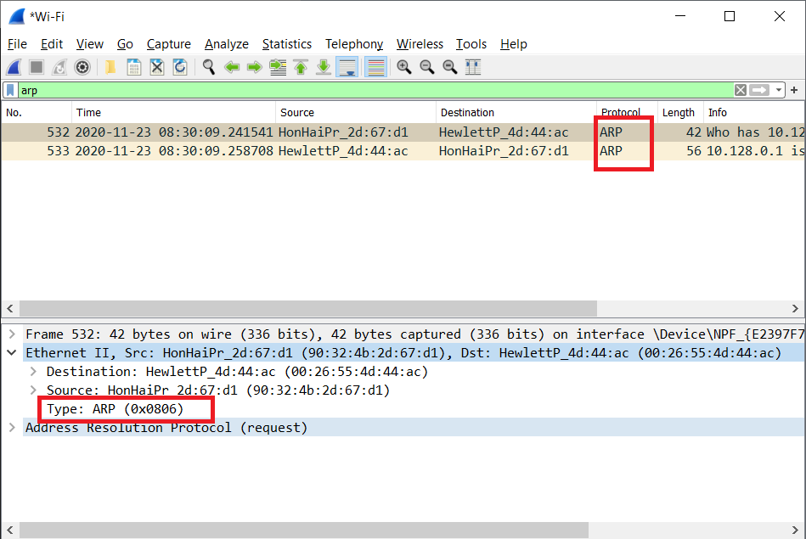

1. a) How many bytes from the very beginning of the Ethernet frame does the ARP opcode field begin?

* The opcode field starts 20 bytes from the beginning of the frame.

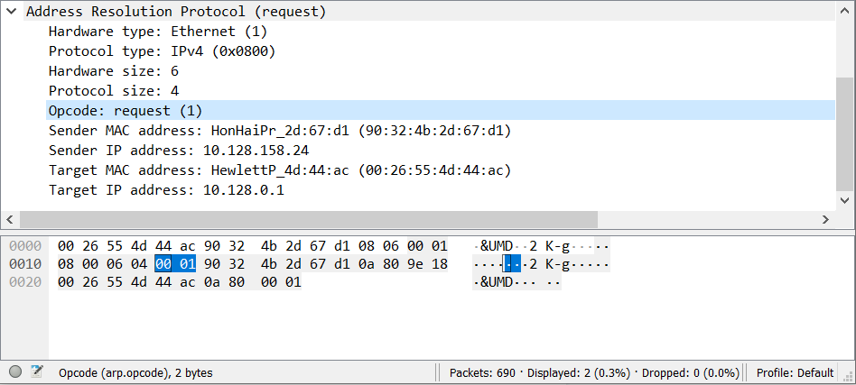

b) What is the value of the opcode field within the ARP-payload part of the Ethernet frame in which an ARP request is made?

* The opcode has a hex value of 0x0001, which is for request.

(the above figure)

c) Does the ARP message contain the IP address of the sender?

* Yes, it does. It is 10.128.158.24

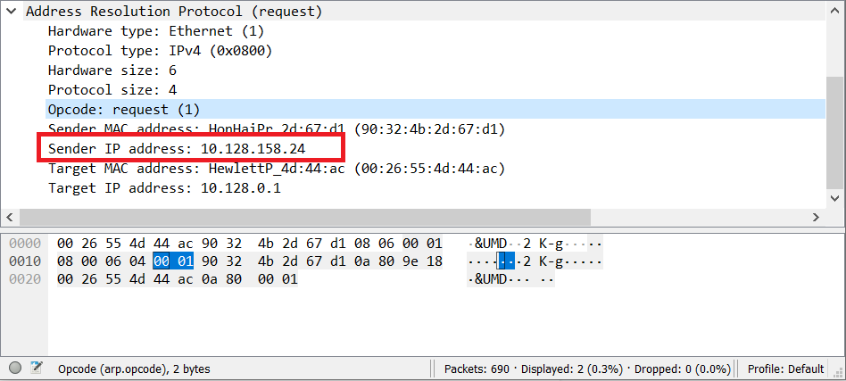

d) Where in the ARP request does the “question” appear – the Ethernet address of the machine whose corresponding IP address is being queried?

* The "question" is in the field Target MAC address.

1. a) How many bytes from the very beginning of the Ethernet frame does the ARP opcode field begin?

* The opcode field begins 20 bytes from the beginning of the frame.

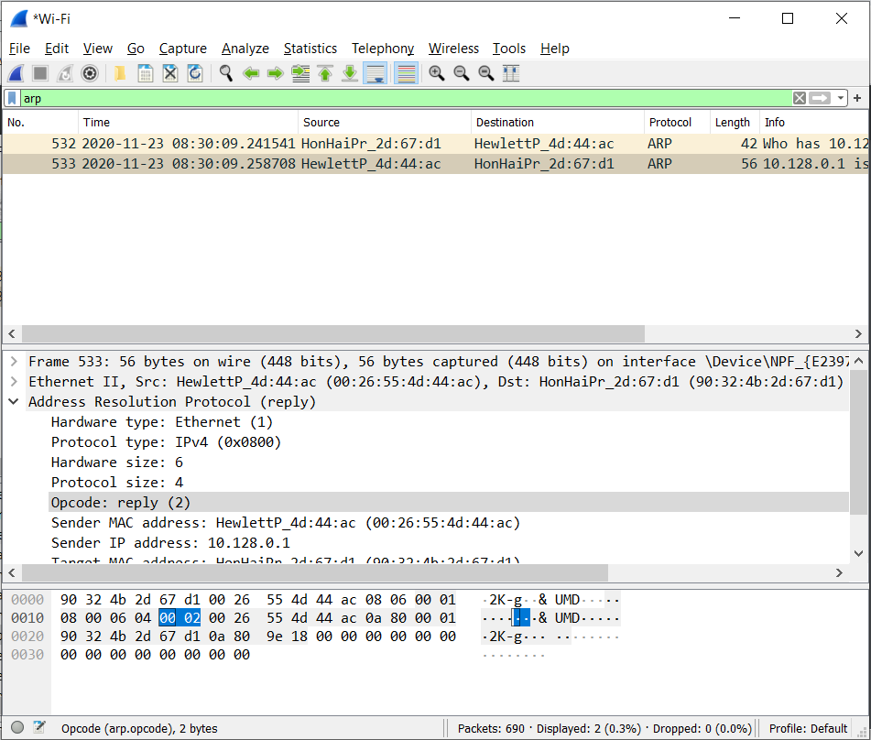

b) What is the value of the opcode field within the ARP-payload part of the Ethernet frame in which an ARP response is made?

* The value of the opcode is set to 2, which is for reply.

(the above figure)

c) Where in the ARP message does the “answer” to the earlier ARP request appear – the IP address of the machine having the Ethernet address whose corresponding IP address is being queried?

* The "answer" appears in the Sender MAC Address field.

1. What are the hexadecimal values for the source and destination addresses in the Ethernet frame containing the ARP reply message?

* The hex values in the frame are for destination: 90:32:4b:2d:67:d1 source: 00:26:55:4d:44:ac

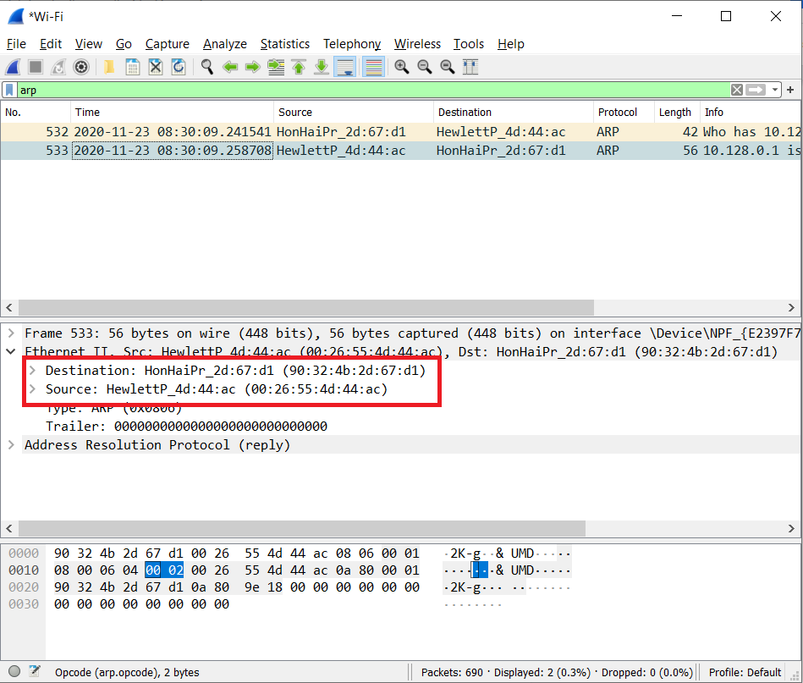

1. Why is there no ARP reply (sent in response to the ARP request in packet 6) in the packet trace?

* We cannot see the reply, because we are not the machine that sent the original request. We can see the reply to our ARP request because it is sent directly to us.